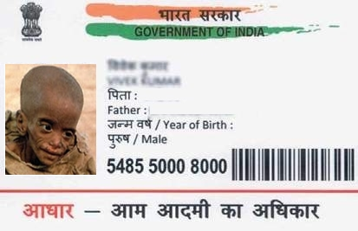

Name Aliya Yadav

DOB 21/08/1996

Gender Female

0 0 0 0 1 1 1 1 2 2 2 2